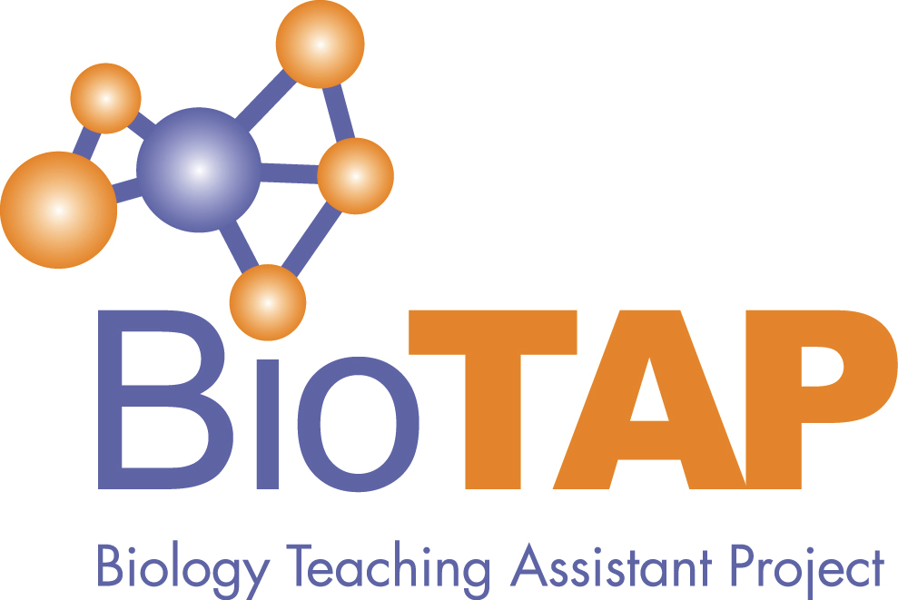
Biology Teaching Assistant Project
2019 Virtual Conference
Tuesday, November 19, Noon – 4:25 PM EST

Open to all interested in Graduate Teaching Assistant Professional Development for Teaching!

Noon – 12:20 Introduction to the Conference and BioTAP
Talk Abstracts

12:20 – 12:40
The Prism Model: A Novel Approach to Graduate Teaching Assistants’ (GTAs’) Pedagogical Content Knowledge (PCK) Professional Development, Cassie Mattox*, Nova Southeastern University (currently at Maryville University)

Abstract: The researcher will share the findings of a study of a professional development model that facilitates graduate teaching assistants’ (GTAs’) self-perceptions of their pedagogical content knowledge (PCK). Two theoretical frameworks were utilized in this study: PCK and experiential learning. Developed by Shulman (1986), PCK is the intersection of content and pedagogical knowledge. Experiential learning theory, developed by Kolb (1984), contributed the critical concepts of experience, reflection, and meaningful action. Previous studies have examined pre- and post-professional development, PCK of GTAs, and various peer observation models (e.g., Reeves et al., 2016). However, this study addressed a gap in the literature by examining a professional development activity that encourages PCK development in conjunction with experiential learning. This mixed-methods study explored how an innovative professional development model (the Prism Model) furthered biology GTAs’ perceptions of their PCK development. The pre- and post-assessments indicated an increase in PCK self-perception along with GTAs expressing a novel scientific literacy orientation towards teaching biology. Additionally, the GTAs noted an array of PCK approaches utilized by their triad partners and reflected on ways they could actively experiment with these novel approaches in their own classroom. These findings indicate an internalization of the Prism Model experience.

12:40 – 12:50
Feedback Hit or Miss: Biology Graduate Students Teaching Scientific Writing Skills to Undergraduates, Melody Danley*, Sheyanne Trent, and Trey Grant, University of Kentucky

Abstract: Within our department, biology graduate teaching assistants (TAs) provide written feedback on undergraduate scientific writing assignments as part of a draft-feedback-revision process. However, it is not clear if TA written feedback aligns with the undergraduates’ feedback preferences or expectations. The purpose of this project was, in part, to assess the undergraduates’ expectations for written feedback on scientific writing assignments. Our study population included 283 undergraduates enrolled in biology courses with scientific writing assignments evaluated by TAs. Each undergraduate participant completed one pre-feedback survey with questions about past scientific writing experiences and the importance of different types of written feedback. Survey responses were analyzed using multivariate, generalized linear models followed by Tukey-Kramer post hoc analyses. Overall, undergraduates tended to score feedback that focused on surface-level errors (e.g. spelling errors) as less important compared to discipline-specific errors (e.g. development of scientific arguments). Undergraduate expectations for written feedback varied significantly based on their self-reported prior publication experience (p<0.003, F-stat = 2.521). Feedback expectations also varied significantly based on the primary written language of the undergraduates (p<0.008, F-stat = 2.247). Our preliminary results suggest that our undergraduates have varying expectations for written feedback. Future research will compare how these undergraduate expectations compare with the actual feedback provided by the TAs.

12:50 – 1:00
Procedure vs. Meaning: Capturing Lab GTAs Interactions With Students in Video Recordings, Iglika Pavlova, Zeynab Badreddine*, and Meg Horton*, UNC Greensboro

Abstract: We conducted a video-based research study to understand the GTA instructors’ interactions with students during introductory biology laboratories. The focus was on how GTA instructors respond to students’ questions during group work, and how students respond to instructor prompting, especially with regard to engaging in reasoning. We compared recordings for a more and less experienced GTA instructor. We coded for the nature of interactions (focused on procedure, calculations, meaning, or other), who initiated the interactions (instructor or the student), and the time that the instructor spent with each student group. The recording was for the enzymes lab which is challenging both conceptually and technically. Our analysis showed that the interactions between instructors and students were mostly focused on the procedural aspects, with little time spent on conceptual links. The two instructors had very different patterns in interaction with students, with one instructor mostly responding when students asked for assistance, while the other instructor was actively circulating and initiating interactions with students. We discuss the impact of these findings for lab design and GTA training.

1:00 – 1:45 Conference Keynote

Networking for Change: Improving Teaching Professional Development
Through Connections, Collaboration, and Community
Ann Austin, Michigan State University

Abstract: Strengthening undergraduate teaching and learning is a major transformational change goal in American higher education. Achieving more evidence-based teaching practices and deeper learning requires a systems approach that involves multiple stakeholders and multiple levers for change. Members of BioTAP are committed to being part of this movement for change. This talk explores ways in which the BioTAP community can become a stronger force for institutional change by implementing a network approach. Drawing on her research team’s study of existing networks whose goals are to improve STEM undergraduate education (including the effective PULSE Biology Fellows Network), Ann Austin will discuss opportunities that BioTAP might consider. Two major strategies involve (1) creating partnerships and connections with allies within higher education institutions and with stakeholders in the external landscape, and (2) developing purposeful plans for sharing expertise and informing institutional practice. The talk will focus on possible partners, topical areas around which to share expertise and inform institutional practice, and specific practical strategies for advancing change (including peer coaching, creating resource repositories, advancing publicity, and celebrating achievements). Key challenges that change networks must manage (including leadership, membership, and sustainability) will be highlighted also.

1:45 – 2:05
A Comparison of Biology Graduate Students Teaching and Research Professional Networks, Joshua Reid* and Grant Gardner, Middle Tennessee State University

Abstract: Biology graduate students' represent the next generation of biology scholars, including faculty members in higher education. The professional development of these graduate students to prepare them for both teaching and research roles is of the upmost importance. Learning to prioritize these complex roles begins when graduate students become socialized into the research and teaching cultures during graduate school (Wulff & Austin, 2004). This socialization occurs through participation in professional networks. Scholarship suggests contextual factors, such as whether they attend a teaching focused or research focused institution, shape these socialization processes (Austin, 2002; Baker, 2009; Staton & Darling, 1989; Wulff & Austin, 2004). This study used social network analysis to explore the social structures of biology graduate students' professional networks at both teaching focused and research focused institutions. Four comparisons were made between the networks. Standard network metrics were used to compare networks (i.e., network size, density, transitivity, and clustering). Results suggest that biology graduate student’s complete professional networks for research and teaching are similar in structure (i.e., network size, density, and transitivity). Current analysis is looking into whether there is overlap between the networks within each university type (i.e., are the same individuals found in both research and teaching networks).
2:05 – 2:15
Innovations in Inclusive Practices: Training Biology Teaching Assistants in Culturally Responsive Science Teaching, Hillary Barron* (University of Minnesota), Julie Brown (University of Florida), and Sehoya Cotner (University of Minnesota)

Abstract: Utilizing pedagogies of empowerment such as culturally responsive science teaching (CRST) in undergraduate classrooms can mitigate the gatekeeping phenomenon often seen in science. Teaching assistants (TAs) engage in more one-on-one time with students than most faculty in undergraduate biology education, yet minimal pedagogical training is offered to them. Therefore, training for improved pedagogical knowledge is important for TAs, but training for culturally responsive science teaching is critical as TAs have broad and lasting impacts on students. Using constructivist grounded theory methods, this study explores the ways training for culturally responsive science teaching impacted undergraduate biology teaching assistants. This study applied grounded theory methodology to develop a theoretical understanding of the TA’s experiences. Two major themes emerged from the data: Targeted Supports in CRST and TA Relationships with Students. These themes describe the ways in which training for culturally responsive science teaching impacted TA practice.

2:15 – 2:45
BREAK (get a snack, walk around, come back!)

2:45 – 3:30 Conference Keynote

Building Capacity for GTA Pedagogical Professional Development: The Role
of Communities of Practice
Erika Offerdahl, Washington State University

Abstract: Despite increasing support for the integration of more student-centered, evidence-based teaching practices, the majority of undergraduate STEM instructors in North America continue to teach didactically. The institutional contexts within which individual instructors are embedded play a significant role in personal decisions instructors make about how to teach. Not surprisingly, several national initiatives have been focused on improving the climate for evidence-based instruction in undergraduate STEM by catalyzing institutional change. Recently, these efforts have been strengthened by fostering opportunities for institutions to communicate, share resources, and leverage support. In this talk, a specific example of a national effort to catalyze change in undergraduate life sciences through the development of regional communities of practice will be presented. From this example, Erika Offerdahl will draw connections to the efforts of the BioTAP community, offer suggestions for how to form and sustain communities of practice, and discuss the role of systems thinking in advancing the BioTAP mission.

3:30 – 3:40
The Science Teaching Experience Program for Upcoming PhDs (STEP-UP): Designing for Effective & Inclusive Instructors, Elaine Klein*, (University of Washington-Seattle) Ben Wiggins (University of Washington-Seattle), Rebecca Price (UW-Bothell), and Rich Gardner (University of Washington-Seattle)
Abstract: STEP-UP is a new program at the University of Washington that provides a mentored teaching experience for Cell & Molecular Biology doctoral students. The program features a course for advanced doctoral students to: 1) learn about active learning strategies and the supporting research; 2) consider how issues of identity, equity, and justice affect science teaching and learning; 3) teach a class session for an audience; 5) develop their practice and identities as educators through self-reflection and feedback. Over the subsequent two quarters, participants (in groups of three) design and teach an undergraduate course. STEP-UP represents a teaching professional development experience advocated for by research, for graduate students to become qualified educators before entering the job market, but that is persistently unavailable during graduate programs. Additionally, STEP-UP directly surfaces issues of equity and identity, with the broader goal of preparing scientists to address some of the inequities in science classrooms. In this talk, we will describe how STEP-UP’s design supported doctoral students in developing their teaching practice and identities during a pilot year of the program, and how our Design-Based Research approach can inform other teaching professional development experiences for science graduate students, especially in the interest of scaling best practices.

3:40 – 3:50
What GTAs Anticipate to be the Long-term Costs and Benefits of an Intro Bio Lab Assistantship with TPD, Frank R. Castelli* and Mark A. Sarvary, Cornell University

Abstract: Graduate teaching assistants (GTAs) were asked at the start of an introductory biology laboratory course what they anticipate to be the long-term benefits that they will receive and the costs that they will incur for being a GTA for this course. These GTAs attend a research-intensive university and receive teaching professional development (TPD) from the course instructors. Long-term was specified as “by the time they graduate and after they graduate.” TPD takes the form of pedagogical readings, training, and discussion at weekly prep meetings. Twelve GTAs were anonymously surveyed in Fall 2019. Some benefits that they anticipated included the development of communication and teaching skills, additional lines on their CV, and an expanded network. Anticipated costs mostly focused on time being taken away from their research projects or other life activities, which some fear may extend time to graduation, and other costs mentioned include a lower quality dissertation and fewer publications. We intend to later compare the long-term benefits and costs anticipated by current GTAs with those actually realized by past GTAs, with the goal of designing an intervention aimed at helping GTAs to maximize the benefits and minimize the costs of this assistantship, which should also benefit their students.

3:50 – 4:00
Can Graduate Students Use Concept Inventories Too?: A Case Study with the Homeostasis Concept Inventory, Emily Royse*, Alexandra A. Vita, Nicholas A. Pullen, and Emily A. Holt, University of Northern Colorado

Abstract: Concept inventories (CIs) are established multiple choice metrics that assess student knowledge and misconceptions on domain topics. CIs have been developed about myriad topics related to biological systems and are typically calibrated to assess undergraduate students. One such example is the 20-question Homeostasis Concept Inventory (HCI), which is validated to assess undergraduate students’ knowledge of core physiology concepts. Our objective for this study was to compare the performance of non-biology majors undergraduate and graduate student populations on the HCI. We administered the HCI to 30 undergraduate Anatomy and Physiology (A&P) students and 24 graduate students who were either enrolled in advanced physiology courses or were teaching assistants for undergraduate A&P courses. Graduate students on average scored significantly higher and within a smaller range (M = 14.08, SD = 2.28, range = 9) on the HCI than undergraduate students (M = 10.50, SD = 4.53, range = 16; independent t-test: t(44.65) = 3.77, p < .001). These patterns indicate that the HCI discriminates novices from experts and captures a spectrum of graduate student physiology knowledge, demonstrating how CIs may prove useful in understanding graduate students’ emerging expertise and help inform what conceptions they bring into the courses they teach.

4:00 – 4:20
Examining the Impact of Responsive Teaching PD for Biology TAs, Matthew Simon* and Julia Gouvea, Tufts University

Abstract: The ability to notice and engage with student thinking is at the core of responsive teaching but can take practice for novice teachers to develop. We developed a video-based PD curriculum for biology TAs that encouraged responsive teaching practices. Five graduate student TAs participated in the PD which ran concurrently with their teaching assignments as introductory biology lab instructors. TAs took turns sharing video clips from their lab sections for discussion and were also responsible for keeping a weekly reflective teaching journal.
In this talk, we present the methods and findings of a preliminary analysis of the TAs’ reflective teaching journals as a way to better understand the noticing patterns they exhibited over the course of the semester. Specifically, we found that TAs often noticed student ideas and then used these moments to reflect further on pedagogical practices or student thinking. The way TAs engaged in these reflections tended to either be evaluative in nature (reflecting on the relative value or success of the teaching move or student thought) or considerate in nature (reflecting on other potential teaching moves or the source of student thinking). The style of these TA reflections will help further refine future iterations of TA PD.

4:20 – 4:25 Conference Wrap-up

The Biology Teaching Assistant Project (BioTAP) is a research coordination network funded by the National Science Foundation (DBI 1539903) to empower universities to use research to improve the quality of graduate student teaching

